Overview Form v2018.10
Space Technology and Applications proposals
This form must be part of any technology funding request to SERI/SSO for funding under ESA programmes requesting national delegation support.

Fill-in all yellow fields

Title of your proposal

[Title]
Description
Short description (10-20 lines) of your proposal and its objective(s). Please refrain from copying the workplan description.

[Abstract]
SSO-ID / Heritage Reference Number

Requestor

Your Company, Inc.
Point of Contact | [Manager]
Register of commerce/UID
Founding year
Experience in space sector | yr | Experience in sector /w respect to this proposal: | yr

Programmatic Frame
If other programmatic frame, please specify

Funding request
k€ |  | (Swiss share only, i.e. total of the CH Cost Breakdown, and excl. co-funding)
Financial envelope for CH | k€ | (incl. co-funded contributions)
Financial envelope in total | k€ | (incl. co-funded contributions)

Detail Information

Tender Information
(http://emits.esa.int)

open ITT

intended ITT

not on EMITS yet / no info
ESA/Tender Deadline

This Proposal is w.r.t.
Title of the ESA Activity
ESA Reference Number |  | Procurement Policy
Funding scheme |  | If other funding scheme, please specify:
Is this a CCN? |  | If yes, indicate initial ESA contract reference:
 |  | If yes, indicate the total initial amount: | k€
 |  | If yes, indicate the total initial amount for CH: | k€

Additional Information about the Activity
Is this a follow-up activity? |  | If yes, provide information:
Does this activity build upon a previous ESA activity? |  | If yes, provide information (title, ref., status, schedule, consortium, deliverables etc.):

Consortium
 | Company / Institute | Country | Costs
Prime |  |  | with a share of | k€ | (incl. | k€ | internal funding)
Subco1 |  |  | with a share of | k€ | (incl. | k€ | internal funding)
Subco2 |  |  | with a share of | k€ | (incl. | k€ | internal funding)
Subco3 |  |  | with a share of | k€ | (incl. | k€ | internal funding)
Subco4 |  |  | with a share of | k€ | (incl. | k€ | internal funding)
Subco5 |  |  | with a share of | k€ | (incl. | k€ | internal funding)
Requestor’s role and responsibilities
If there are more than 5 subcontractors in the consortium, please extend the table above.

Product / Market Fit from a company perspective
Market Type  What kind of market will this product / Service serve? |  | 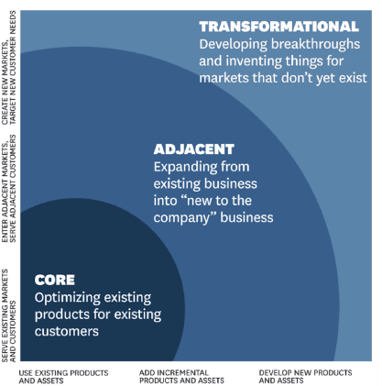
Product Type

What kind of product will you develop?

Cost Break Down (CH share only)
Outsourced fabrication/services | k€ | Description:
Procurements | k€ | Description:
Jigs & tools | k€ | Description:
Travel expenses | k€ | Description:
Labor | k€ | Description:
Subtotal | k€
(Company co-funding) | - k€ | Subtract the company co-funding (if applicable)
Total  (Funding request) | k€ | If there are no cost planned for one or more cost centre, please explicitly indicate this with “0 k€”.

Workplan & Proposal Details
Starting / ending TRL | /
Planned Kick-Off date |  | Total (overall) project duration: | months

Phase 1 | Scope
 | Duration | months
 | Deliverables
 | Cost | k€ |  | (only CH share but including ESA & internal funding)

Phase 2 | Scope
 | Duration | months
 | Deliverables
 | Cost | k€ | (only CH share but including ESA & internal funding)

Phase 3 | Scope
 | Duration | months
 | Deliverables
 | Cost | k€ | (only CH share but including ESA & internal funding)

If there are more than 3 phases, please extend the table above.

Total workload requestor | man hours | Total workload CH | man hours | (1 man year = 2050 man hours)

IPR & Commercialization
(Intellectual Property Rights)
Current IPR owned by |  |  | Current IPR exploited by
Generated IPR owned by |  |  | Generated IPR exploited by
Declaration of interest for subsequent commercialization? |  |  | If yes, please provide letter of interest (or similar) in the annex of your proposal.

Company (requestor) relevant information
 |  | Space Market |  | Non-Space Market
 |  | Company in CH | Subsidiaries outside CH | Company in CH | Subsidiaries outside CH
Annual turnover | (year ) | kCHF | kCHF | kCHF | kCHF
Number of employees (FTE)
R&D share (Financial)  Internal R&D funding / total income |  | ~ % | ~ % | ~ % | ~ %
R&D share (Staff)  R&D employees / total employees |  | ~ % | ~ % | ~ % | ~ %

This form was filled in by | [Author] | Place |  | Date

Nota bene:

- Return this document in Word (.doc or .docx) format.
- Note that a Funding Request to SERI/SSO consists of an Overview Form (this form, including Basic and Detail information) and a Project Description (following our guidelines published on the internet). SERI/SSO will acknowledge the reception of a funding request and attribute an internal reference
- Please provide as part of your proposal the following project management elements: WBS (including WP owner, cost, work load, scope, duration) with a particular focus on the requestor’s responsibilities, WP description, Gantt chart and cost calculation.
- Please note that ESA will gladly provide you with all the information you need upon your request (e.g. if SoW not yet available).

